You can find the codes at: /uufs/chpc.utah.edu/common/home/flin-group8/gzaldi/guide_practice_CC_FTAN

Data preparation:
Make sure files are named in a consistent way:
d downloaded file  rs removed response  syn synchronized files to 0 s | 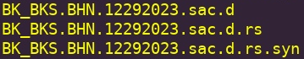

If downloading from IRIS, make sure to download corresponding response files: network.comp.MMDDYYYY.pz
Comp: BHZ BHN BHE (even when using HHZ, unless you will be changing codes)
Download station information file (if IRIS) or prepare it. File A: gmap_[network]
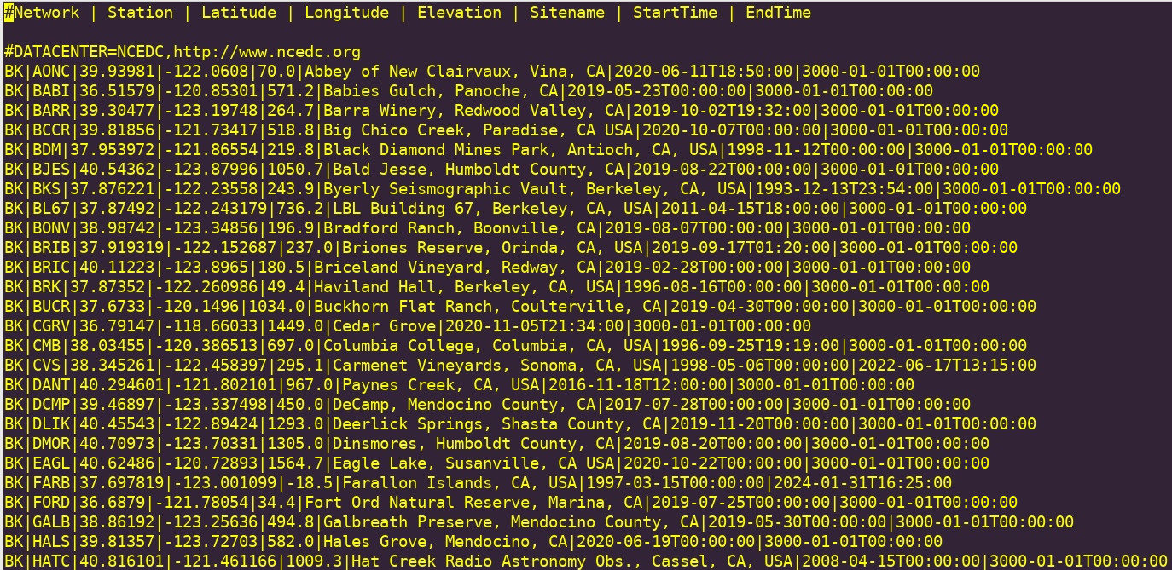

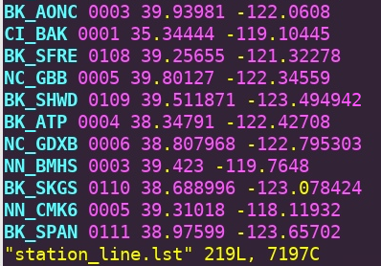
And station list file (will be useful for steps ahead):
File B: station_line.lst

You can use whatever you prefer to download from IRIS, but I’ve included sample .py codes to guide (?) the process. Modify to work for you! Check out download_files.py and remove_resp_loop.py. These are suitable for data that has been downloaded from IRIS. Note: it’s normal that there’s data missing for some days/months or stations.

In some cases the files might be downloaded in a “chopped” way (multiple files for a same day) so you should merge them before moving with any pre-processing. Chek out merge_raw.py.
E.g.:
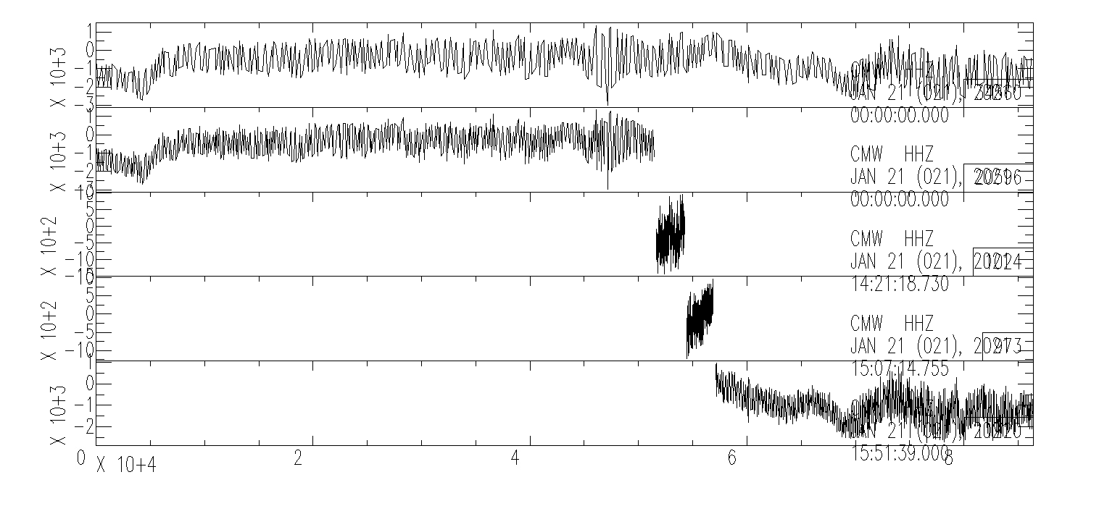
merged
If using geophone data from the department, then use the next bash scripts:

Remove the instrument response: For a single response file
Highlight: We remove non-zero mean values and the instrument response in this step. & decimate
Action code: resp_stationwise.csh
Required: Cshell and SAC
Usage: ./resp_stationwise.csh (station name) (response dir) (component 1) ... (component n)
station files should be in the following structure: (station)/(date).(staname).(comp).sac
Output: (station)/MMDDYYYY.(staname).(comp).sac.rs
Example: ./1_resp_stationwise.csh BK_BDM /uufs/chpc.utah.edu/common/home/flin-group4/gzaldi/north_california_data/response HHE HHN HHZ
Comparing before vs. after
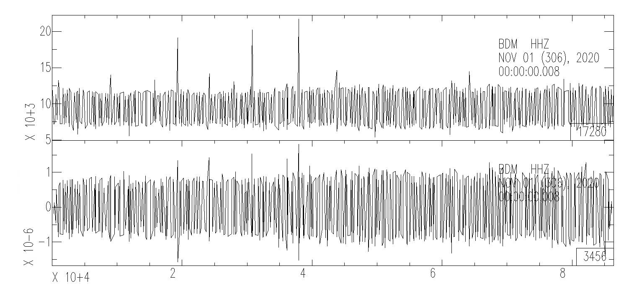

Synchronize the data
You can skip this step if the data is organized daily from 00:00 however, be careful with naming files for the next step!
Purpose: Data are acquired not in the same time reference (between stations) due to the different deployed time.
Action code: syn_data_rs.csh
Required: Cshell and SAC

Usage: csh syn_data_rs_mod.csh [network_station]
Output data: (network_station) / (network_station).BHE.MMDDYYYY.sac.d.rs.syn

additional: if you want to loop it through many files, check out run_syn.csh. You will need to use file A as input.

Cut the daily raw data into small chunks (e.g. 5-minute window).
The time window will depend on how separated stations are in your array. E.g. North Calironia end to end was approx.. 600 km, therefore I used 900 s (15 min) to properly see the Rayleigh wave moveout in the record plots.
Purpose: Cut into small windows and ready for cross-correlation.
Used fortran scripts: cut_seis.f, compiles as cut_seis.new (** In HyeJeongs directory)
Required: fortran
Usage: ./cut_timesegments_stationwisemod.csh (in directory of stations) (out) (tail) (tlength) (component 1) ... (component n)
Output: (out)/(staname)-(index)/(date)(time of the day).(staname)-(index).(comp).sac

Station files should be found in the following structure: (in dir)/(staname)/(date).(staname).(comp).sac.(tail)
“out” is the name of the output directory
Tail will be your last processed file: d.rs.syn
Length will be in seconds: 15min = 900s, 5 min = 300 s
Location for this code should be outside your stations directories.
e.g: From the name you can check you have the correct time windows!
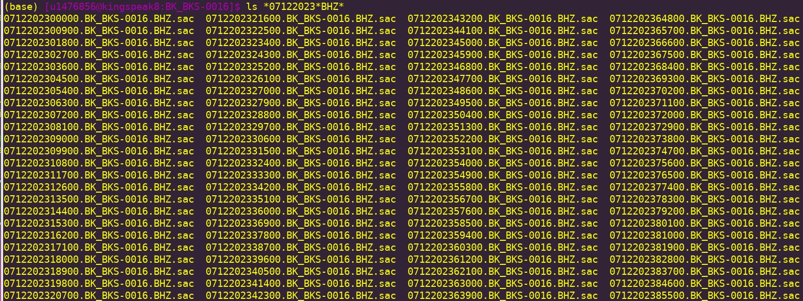

Remove mean and trend for the new small segments
Remove the mean and trend for the small segments from the previous step.
Usage: ./rmean_rtrend_bulk.csh (output directory from previous step)
Output: the same files, with the same name. It writes over original file.

Cross-correlations and stack
Get the cross-correlation functions and preserve the relative amplitude across the 9 components. This step will perform 9-component cross-correlation functions with the 3 components (Z E N), so we will have 9 output directories (ZZ ZE ZN EE EN EZ NN NE NZ).
The latest directories that contains the CC code is named: CCF_9comp.verHjK5. This has been updated to do the following:
It create directories
It automatically remove traces with zeros over limit or too large or too small amplitudes . The parameters defined by
- #define zerolim 600
- #define YMAXLIM 1.E-1
- #define YMINLIM 5.E-10
This version normalizes the waveforms per station. This might need to be changed depending on your array or study. (In some cases you might want to normalize per array!)

Usage: ./CCF_9comp/cor_whiten_nor_stack.v4 timelist.txt 0 (number of stations in input data) station_line.lst (path to your segmented data)
Output: stack_all/(comp)/COR_(station1)-(station2)_(comp)_stacked.SAC

Location for this directory: inside your “out” directory from pervious steps.
Run it in the “out” directory
In the “out" directory you must also have the station_line.lst (File B) and a timelist.txt file. When working with many months or many stations, it is recommended to CC in shorter time ranges for better computer processing (and quality control checks!). So you can either manually creates the timelist or just code a simple script to exatract the dates you’d like. (e.g. date_extract_month.csh).

There might be some things you want to modify in your CC, if so, you will need to revise the parameters in main.c and recompile. This includes:
numsts: number of stations you’re using
numcents: number of stations + 1
seg: number of time segments (depending on the length of timelist)
LAG: the output CC length (one side), this is number of data points.(NPTS)
LAGFFT: its calculated based on NPTS. E.g: NPTS=1800, then 1800x2 = 3600. So, 2^x > 3600 x = 12m 2^12 = 4,096 (this is LAGFFT!)
SAMPLE_DEL: sampling rate of your data
nthreads: cores used when you do parallel computation, currently set at 20. Please be aware of the limits in the server you’re using.
If you need to change comp name, revise lines 132-134
If you need to change input format, revise line 145
If you need to change output format, revise line 352
The CCF output is the stacked for the time duration in the input time list, e.g. if you ised 1 month and have 3 months, then you’ll need to stack those results!

After modifying for your data in main.c please recompile!
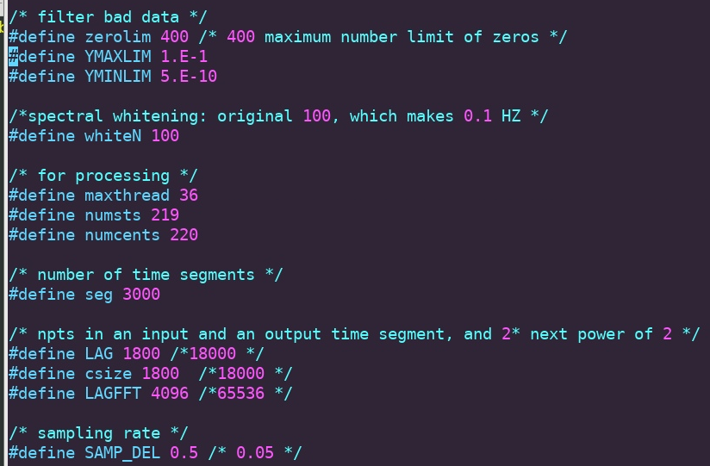

Examples of results:
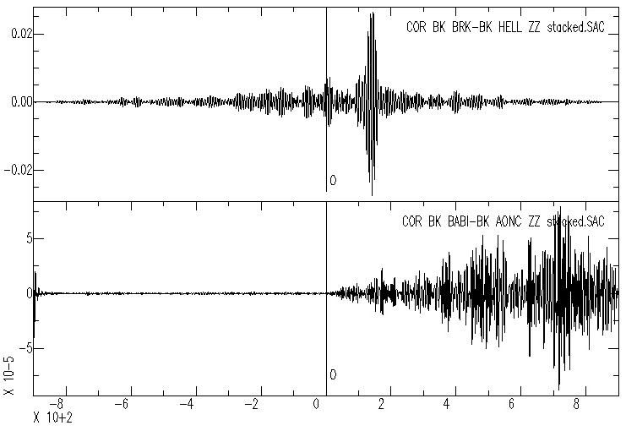

BRK-HELL has a clear CC max amplitude for the ZZ component. However BABI-AONC is noisy and asymmetrical. This comes from an issue from the input files, perhaps the raw waveform in the vertical component presents issues… (In this case BABI is the problem!)
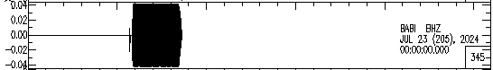

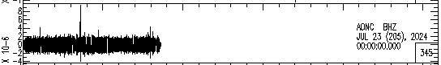

In some cases some stations will have issues with specific components…. For example BABI seems to have issues in its vertical component:
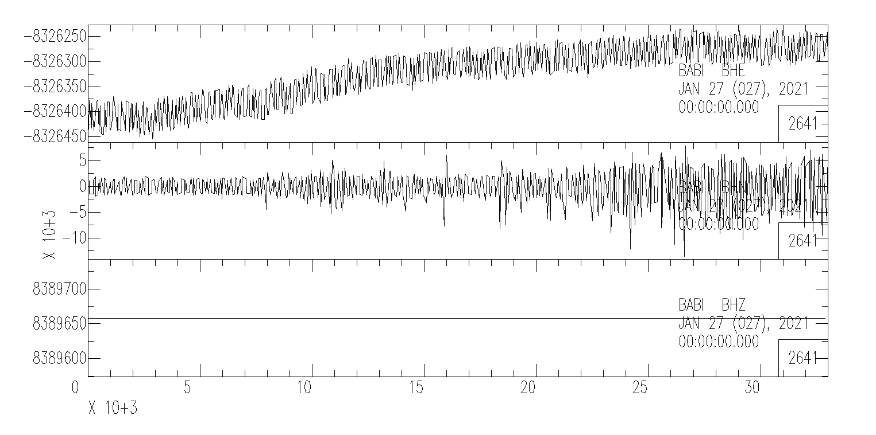

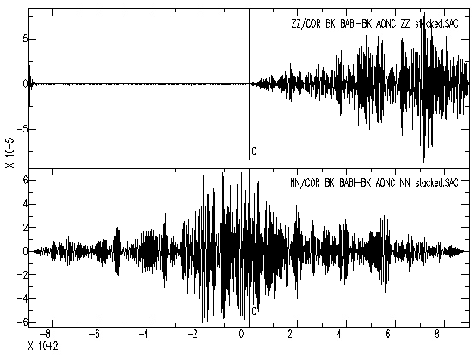
This will means that in your CC’s some components will have “better” CC’s than others even for the same station pair!

Still noisy… but a bit better!

You can start checking particle motions and waveforms with SAC. E.g:
Waveforms:
r ZR/BK_BKS-BK_LLNL_ZR_stacked ZZ/COR_BK_BKS-BK_LLNL_ZZ_stacked.SAC RR/BK_BKS-BK_LLNL_RR_stacked RZ/BK_BKS-BK_LLNL_RZ_stacked
bp c 0.1 0.2 n 4 p 2
qdp off
p1

PPM:
r ZR/BK_BKS-BK_LLNL_ZR_stacked RR/BK_BKS-BK_LLNL_RR_stacked
bp c 0.1 0.2 n 4 p 2
xlim 25 125
xlabel "RR"
ylabel "ZR"
ppm

r ZZ/COR_BK_BKS-BK_LLNL_ZZ_stacked.SAC RZ/BK_BKS-BK_LLNL_RZ_stacked
bp c 0.1 0.2 n 4 p 2
xlim 25 125
xlabel "RZ"
ylabel "ZZ"
ppm

